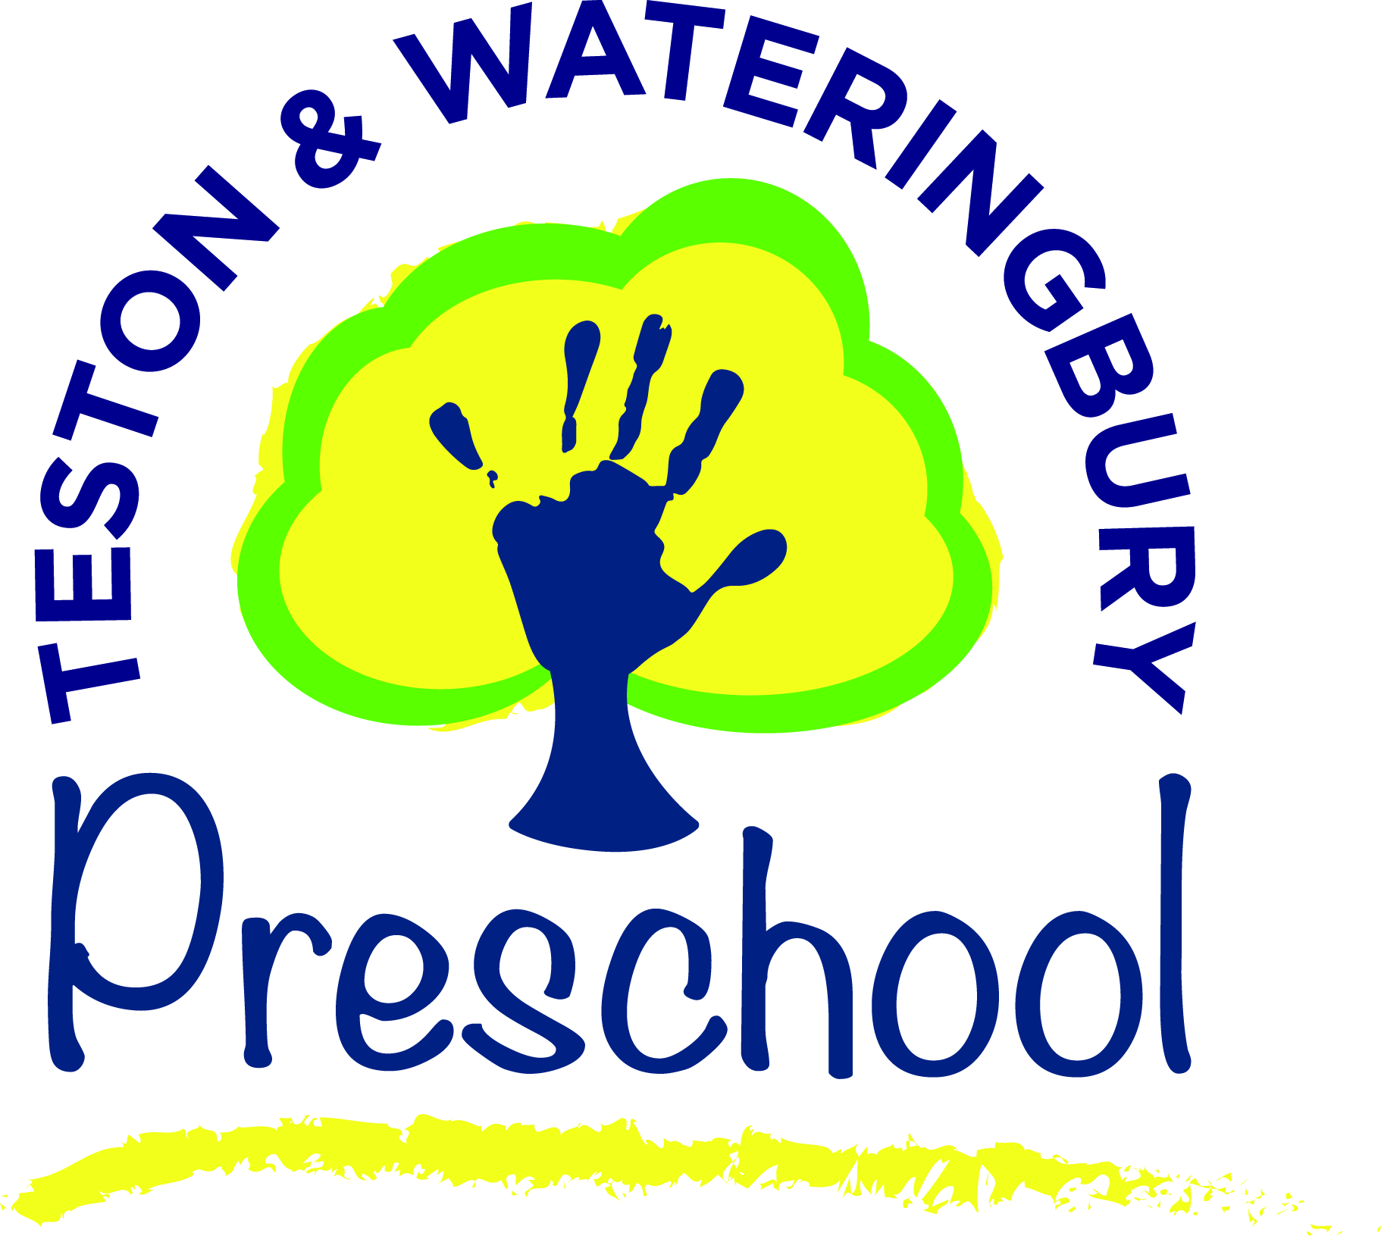

THE EARLY YEARS FOUNDATION STAGE POLICY

Every child deserves the best possible start in life and support to fulfil their potential. A child’s experience in the early years has a major impact on their future life chances. A secure, safe and happy childhood is important in its own right, and it provides the foundation for children to make the most of their abilities and talents as they grow up. When parents choose to use early years services they want to know that provision will keep their children safe and help them to thrive. The Early Years Foundation Stage (EYFS) is the framework that provides that assurance.
Statutory Framework for the Early Years Foundation Stage

_____________________________________

Statement of intent:
Teston & Wateringbury Preschool is committed to using the EYFS framework to provide a varied, fun and stimulating curriculum for all children in an inclusive way so that every child is stimulated, challenged and, above all, has fun while learning, developing and being cared for at our pre-school.

Aim:

We aim to do this by:

- Ensuring we meet all the legal requirements relating to the learning, development and welfare of our children;
- Using the four themes/principles of the EYFS and the seven areas of learning and development - see below – to ensure we provide individualised learning, development and care through planned, purposeful play, with a balance of adult-led and child-initiated activities.
- Encouraging parental involvement through sharing information, involving them in their child’s development and learning through an ongoing dialogue and by offering support for extended learning in the home.
- Ongoing assessment of children through systematic observations and assessments of children. These are then used to identify learning priorities and plan relevant and motivating learning experiences for each child taking into account their needs, interests and stages of development. The Key Person system is an important part of this process too;
- Regularly reviewing our activities based on feedback from children, parents, staff and external advisers to ensure we are always improving on what we do and how we do it.

The four EYFS themes:

1. A Unique Child

Teston & Wateringbury Preschool recognises that every child is a competent learner from birth who can be resilient, capable, confident and self-assured. We recognise that children develop in individual ways and at varying rates. We value the diversity of individuals
within the pre-school and encourage the children to also value diversity in others.

We are committed to ensuring that all children, irrespective of ethnicity, culture or religion, home language, family background, learning difficulties or disabilities, gender or ability have the chance to experience a challenging and enjoyable programme of play, learning and development.

Please also refer to our EQUALITY, DIVERSITY & EQUAL OPPORTUNITIES POLICY.

2. Positive Relationships

We recognise that children learn to be strong and independent from a base of loving and secure relationships with parents and/or a Key Person and Teston and Wateringbury Preschool is committed to developing good relationships with all children and their families.

We positively encourage parents to visit the setting with their child prior to starting pre-school and to share information with us to help with the settling in process. We also offer parents regular opportunities to talk about their child’s progress and hold formal meetings with parents every year to discuss Learning Journeys and other matters. We use a platform called ‘evidence me’ to send observations to parents to help extend the child’s learning at home and supply a home school contact book to every child to exchange information with parents/carers.

We aim to provide a smoother transition to primary education by arranging visits to the local primary school and inviting the primary school reception teacher to our pre-school.
In line with new guidance (2021) we also work with parents and Health Visitors (where appropriate) in completing a two-year check to ensure that any concerns are highlighted at an early stage.

Please also refer to:
SETTLING IN POLICY
PARENTAL INVOLVEMENT POLICY.

3. Enabling Environments

Teston & Wateringbury Preschool recognises that the environment plays a key role in supporting and extending children’s development and learning. This begins by observing and assessing their interests, development and learning and then using this information to ensure that future planning reflects identified needs.

The hall is organised in such a way as to allow the children to explore and learn securely and safely. There are areas where the children can be active, be quiet and rest. We also developed the outdoor area to incorporate an all-weather artificial surface for all year round outdoor play. We also had the main grassed area re-turfed to make outdoor play safer and more suitable. We use these outdoor areas as much as possible enabling the children to do things in different ways and on different scales than when indoors. Outdoor play offers them the opportunity to explore, use their senses and be physically active and exuberant and also to appreciate wildlife and the natural environment.

We offer ‘free flow’ sessions where children can choose to play indoors or outdoors when they want to. Parents/carers are asked to send their children to pre-school in shoes suitable for both indoor and outdoor play.

4. Learning and Development

We appreciate that children develop and learn in different ways and at different rates and that all areas of learning and development are equally important and inter-connected.

Through play the children explore and develop learning experiences which help them to make sense of the world. They practise and build up ideas and learn to control themselves and understand the need for rules. They have the opportunity to think creatively alongside other children as well as on their own. They communicate with others as they investigate and solve problems.

We also encourage active learning through physical and mental challenges involving other people, objects, ideas and events that engage and involve children for sustained periods. Children learn to make decisions which also gives them a sense of satisfaction.

We give the children the opportunity to be creative through all areas of learning, not just through the arts and the staff support their learning by helping them to make connections. They do this through encouragement, showing genuine interest, clarifying ideas and asking open questions. Children can access resources freely and are allowed to move them around to extend their learning.

The seven areas of learning and development consist of three Prime Areas:

1. Personal, Social and Emotional Development (PSED)
2. Physical Development
3. Communication and Language (CL)
Plus three Specific Areas:
4. Literacy
5. Mathematics
6. Understanding the World
7. Expressive Arts and Design
None of these areas of learning can be delivered in isolation from the others. They are equally important to ensure a rounded approach to child development. Teston & Wateringbury Preschool aims to deliver all seven areas through planned, purposeful play, with a balance of adult-led and child-initiated activities.

Additional information

A copy of what, where, when can be found on our website for parents to help with understanding children’s milestones and we are also happy to lend a copy of the EYFS Statutory Framework to parents.

